4 Transitions and Mixins

Contents

The _config.scss file 1

The main.scss file 1

Testing the Hover Color Change 2

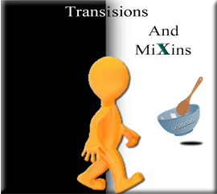

Here we will be creating a transition to smoothly transition into the hover color change of the social icons.

# The _config.scss file

We will be creating the @mixin inside of the _config.scss file. So, open that file.

Setting it to all, will allow us to reuse this transition. We could just set it to color, or position or something specific. But since we want to be able to reuse this transition, we will set it to all.

Transition is the property, notice that we only use spaces to separate the three attributes of the Transition rule; what we want to target: how long we want it to take: and the specific transaction we want to use.

You can go [here](https://www.w3schools.com/css/css3_transitions.asp) to W3schools learn more about transition



# Creating the @mixin Transition

This transition will make our social icons slow down and smoothly transition to the desired set color, when we hover over each icon.

Look at what is inside of the @mixin code block. The property of transition, is put behind a colon wall. And, what you want to set the property’s attributes to represent, is set behind a semi-colon wall. Then you are just wrapping the entire thing all up in curly braces.

Ok, so the above was just a type of memory technique, to reinforce what is going on in the code below.

@mixin transition-ease {

transition: all 0.5s ease-in-out;

}

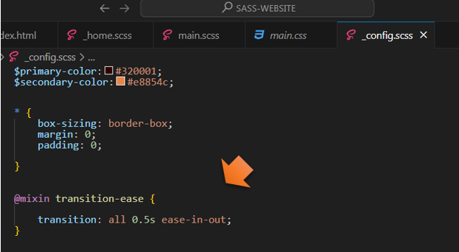

# Assigning the @mixin to be used Somewhere

# The main.scss file

In order to use our new @mixin, we need to @include it somewhere. Here we want to target the hover, on our social icons, which are inside of the .main rule.

@include transition-ease;

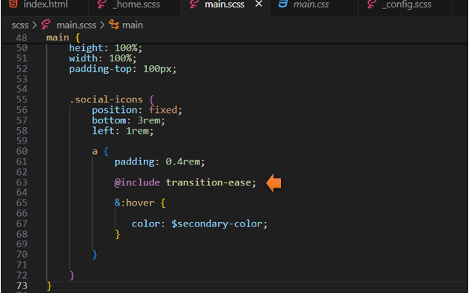

# Testing the Hover Color Change

Now when you hover over your icons, you will notice that the hover color changes slowly, it eases the transition of the color change.

